


Consent Form
(to sign and give back to Lizzie)

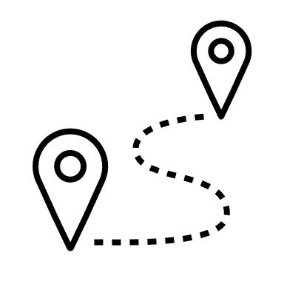
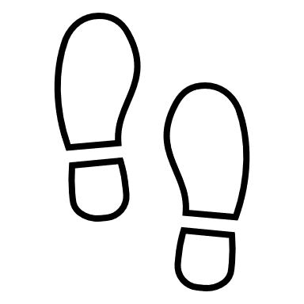









Woolwich Wandering

Please read the information sheet before signing this form.
Lizzie Fort
Dance Artist-Researcher-Educator
07881 508057
lizziecfort@gmail.com
forte@roehampton.ac.uk
Twitter @dizzfort Insta @lizzfort
You can complete this form electronically and email it to Lizzie (lizziecfort@gmail.com)
OR
You can complete it by hand and arrange a Covid-safe collection with Lizzie.
Please keep one copy of the form for yourself.

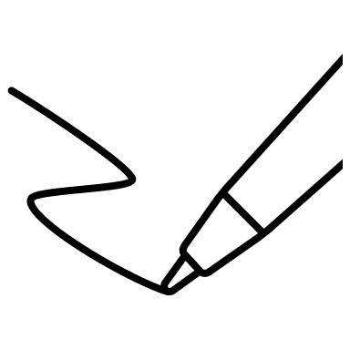
I [insert name]
Would like to participate in the following activities (PLEASE CHECK BOXES):
Walking task: ☐ Yes / ☐ No Photo Journals: ☐ Yes / ☐ No
I agree to take part in this research and I understand:
- The purpose and nature of the study and I have had the opportunity to ask questions about the study.
- That I am free to withdraw at any point without giving a reason by contacting the researcher Lizzie Fort.
- That if I do withdraw, my data may not be erased but will only be used in an anonymised form as part of an aggregated dataset.
- That the personal data collected from me during the course of the project will be used for the purposes outlined on the information sheet in the public interest.
- The conversations with the researcher Lizzie Fort after the walking and photo journal activities will be audio recorded and that I will have an opportunity to change or delete information from the transcripts.
- The information I provide will be anonymised, unless I tell the researcher Lizzie Fort that I wish to be named.
- I will not be paid for my participation in this research. I may benefit from participating by meeting new people from different backgrounds, developing confidence and communication skills.
- I retain the copyright of my contributions, and will be credited with my name, unless I opt to adopt a pseudonym or wish to remain anonymous. The researcher Lizzie Fort will use and exhibit my submitted tasks as part of her research, which might include but is not limited to online and print publication, publication via exhibition and via audio-visual presentations. Lizzie Fort will use the following wording to credit my contribution: © participant name 1, participant name 2 etc. / Lizzie Fort / part of Woolwich Wandering, 2021
- If I inform the researcher Lizzie Fort that myself or someone else is at risk of harm they may have to report this to the relevant authorities - they will discuss this with me first but in some situations may be required to report with or without my permission.
- If I have any concerns that may arise as a result of participation, such as physical or emotional discomfort, I can discuss this with the researcher Lizzie Fort or other contacts listed on page 4.
By signing this form, you are confirming that you have been informed about and understand the University’s Data Privacy Notice for Research Participants. The information you have provided will be treated in confidence by the researcher and your identity will be protected in the publication of any findings. The purpose of the research may change over time, and your data may be re-used for research projects by the University in the future. If this is the case, you will normally be provided with additional information about the new project.
How did you hear about this research project? (please check relevant box)

☐ I was contacted directly by researcher (email/phone/in person)
☐ I saw an advert on social media, poster, flyer and got in touch with researcher
☐ I was contacted indirectly through an organisation I am associated with (with permission) State organisation here:
PLEASE FILL IN EITHER SECTION A or B

A: consenting your yourself OR B: consenting for someone else

- If you are consenting for yourself:
Name [insert name]

Signature or type name here

Date [insert here]
☐ Please check box if you wish to be named in the research and waive your right to anonymity.
☐ Please check box if you would like to have your hand-made materials back once the research has submitted her final PhD paper in March 2024.

- If you are consenting for someone else:
I [insert name]

am consenting on behalf of [insert name]
I can confirm I have permission to consent on their behalf and that I have explained the project before obtaining consent. I can confirm that they voluntarily agree to participate in this research.
Signature or type name here

Date [insert date]
☐ Please check box if the person you are consenting for wishes to be named in the research and waive their right to anonymity.
☐ Please check box if the person you are consenting for would like to have their hand- made materials journal back once the research has submitted her final PhD paper in March 2024.

Please note: if you have a concern about any aspect of your participation or any other queries please raise this with the investigator (or if the researcher is a student you can also contact the Director of Studies.) However, if you would like to contact an independent party please contact the Head of School.

Director of Studies contact details:  Dr Efrosini Protopapa, School of Arts, University of Roehampton, Roehampton Lane, London SW19  e.protopapa@roehampton.ac.uk  020 8392 3654 | Head of School contact details:  Prof. Annabelle Mooney, Head of School of Arts, University of Roehampton, Roehampton Lane, London SW19  a.mooney@roehampton.ac.uk  020 8392 3000

Should the Head of School change over the lifecycle of the research project the new Head of School will become the independent contact. Contact details for the new Head of School can be obtained from the researcher.

