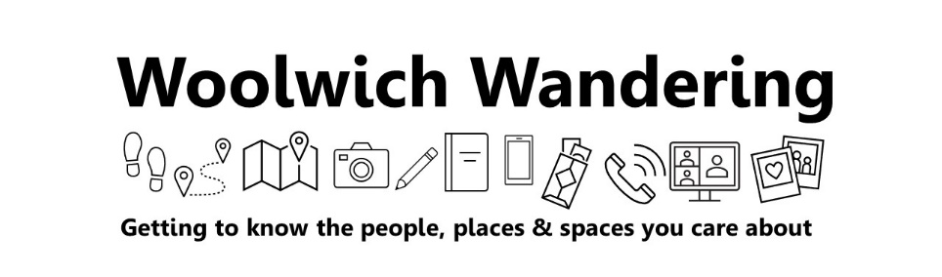
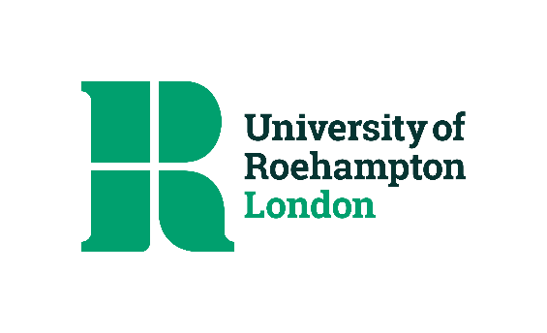

Dear research participant

Thank you for your interest in taking part in the artistic research project, Woolwich Wandering. This project conducted by Lizzie Fort (the “artist-researcher”), a local dance artist and researcher who is investigating the role and purpose of ‘care’ in the work of community dance artists. Lizzie is interested in how walking and pausing/resting/stillness might be considered as acts of care for Woolwich. The official title of the academic research is “Caring and Sharing: Rethinking Community Dance as a Curatorial Practice”…but Lizzie’s more snappy project title is “Woolwich Wandering”. This consent form is for people who are participating in activities from September to December 2022. It is open to previous participants who took part in 2021, and to new people.

Phase 1 overview March 2021 to July 2022

Previously, during the Covid pandemic, 12 local people completed photo journals, walking routes and map making activities and had one-to-one Zoom conversations with the artist-researcher. You can see extracts from the creative activities here:
- Community contributions - https://woolwichwandering.wordpress.com/community-contributions/
- Interactive Map - https://woolwichwandering.wordpress.com/interactive-map/

This preliminary research identified the following themes that mattered to local people: access and lack of access to public spaces; personal safety and security; and gentrification.

Phase 2 Activities, September to December 2022

In Phase 2, the research will explore what it means to slow down and pause in public spaces and proposes that resting, dwelling, lingering or stillness can be experienced as acts of care. This can enable people to better understand their relationship to where they live, what they care about and what they want to change. The proposed series of wandering/pausing workshops will generate collaborative participant statements for a ‘Care Manifesto for Woolwich’, to be sent in the form of an ‘Open letter’ to Royal Borough of Greenwich. The project will culminate in a ‘Town Hall/Square’ style exhibition, co-curated with local people. Participants are invited to participate in as many of the activities as they like.

- Wandering/Pausing group workshops. Prearranged dates in September to October 2022
The artist-research will lead two-hour, group wandering/pausing workshops where participants are gently prompted to wander and pause in Woolwich, documenting their experiences in creative ways. Pausing might involve sitting, standing, leaning, lying down, napping, chatting, reading, eating and drinking in busy thoroughfares or much quieter spaces. The workshop will aim to generate collaborative Manifesto statements. Aspects of the workshop will be filmed and photographed. Participants can opt out of this and still participate. It is anticipated that these experiences will generate rich discussions about:
- Who has access and who does not have access to public space?
- What activities and behaviours can legitimately take place in public spaces?
- How do people want to use their public spaces?
- What encourages people to slow down, pause and rest?
- How should public spaces look and feel?
- Personal safety, security and surveillance in public spaces
- Privately owned public spaces, or POPs
- Public rights of way

Afterwards, participants will have the option to have a 15-minute personal debrief by phone with the artist-researcher to gather any private feedback on the experience.

- Wandering/Pausing experiences for people to do in their own time. September to October 2022
Using briefing information (written and audio) available on the project Blog, participants will be gently prompted to wander and pause in Woolwich, taking time to document their experiences in creative ways (by hand or digitally). This activity could be a short as 30 minutes or take a whole day. There is the option to receive an activity pack, which includes a seat cushion, notepad, pen and creative viewing frames. Activity packs will be delivered to participants and collected afterwards. Participants will be asked to briefly report back to the artist-researcher with their discoveries and Manifesto statements. This can be done by email, WhatsApp, or through an audio-recorded conversation in person or on the phone. This should take no more than 15-minutes.

- Care Manifesto and Open Letter. November 2022
Collaborative statements will be curated by the artist-researcher into a Care Manifesto for Woolwich and sent in the form of an Open Letter to Royal Borough of Greenwich.

- Town Hall/Square style Exhibition. End November 2022
Participants are invited to help curate a public exhibition over three days, that displays the materials generated in Phase 1 (journals and maps), and phase 2, (Care Manifesto and Open Letter). This will involve the careful actions of gathering, organising, assembling, displaying, connecting, re-assembling, re-displaying, dismantling and packing up the project’s materials. Participants can take part in as much of the process as they like.

Contribution to Co-Creation

Participants’ contributions to the project are viewed as collaborative. Participants will be credited for their work on the project blog, in the Manifesto and Open Letter, at the exhibition and in any materials that are generated in the dissemination of the research. This includes but is not limited to written, digital and audio-visual presentation formats. The exhibition and any derivatives of (i.e. films, photography, marketing materials, text, audio recordings etc) will remain the property of the researcher in perpetuity. To credit contributions, participants can opt to be named, anonymous or use a pseudonym (see consent statement on page 3, “Anonymity”). All participants under 18 will automatically be anonymous. Photos and videos may show people’s faces and participants may be identifiable. Adult participants and parents consenting for under 18s can opt to have their faces blurred.

Investigator contact details

Elizabeth (Lizzie) Fort. School of Arts, University of Roehampton, Roehampton Lane, London SW15 5PU. University email: Forte1@roehampton.ac.uk / Mobile: 07881 508057

Consent Statement
I agree to take part in this research and am aware that I am free to withdraw at any point without giving a reason by contacting Elizabeth Fort. I understand that if I do withdraw, my data may not be erased but will only be used in an anonymised form as part of an aggregated dataset. I understand that the personal data collected from me during the course of the project will be used for the purposes outlined above in the public interest. By signing this form you are confirming that you have been informed about and understand the University’s Data Privacy Notice for Research Participants.

For child participants, the privacy notice sets out how your child’s personal data will be used as part of the research project. No identifying details of children will be shared publicly, including photos where children may be visible. By signing this form, you are confirming that you have explained the content of the Data Privacy Notice for Research Participants to your child.

The information you have provided will be treated in confidence by the artist-researcher and your identity will be protected in the publication of any findings. The purpose of the research may change over time, and your data may be re-used for research projects by the University in the future. If this is the case, you will normally be provided with additional information about the new project.

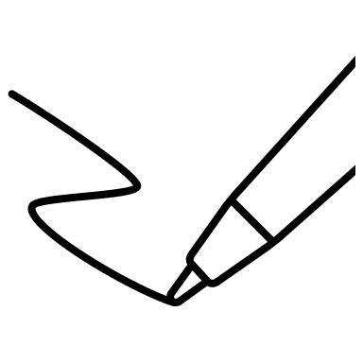
Name ………………………………….
Signature ……………………………… Date ……………………………………

Permission for the artist-researcher to share contributions publicly:
I agree that the ideas and materials I contribute may be: used in collective form in the Manifesto, Open Letter and Exhibition; uploaded to the Woolwich Wandering Blog; used to develop the Online map; used by the artist-researcher in the dissemination of the research.
Name ………………………………….
Signature ……………………………… Date ……………………………………

Anonymity:
Please check ONE box to indicate your preference for being anonymous, pseudonymous or named in the research. You can change this at any time by contacting the artist-researcher.
☐ I wish to be anonymous in the research outputs (all under 18s)
☐ I wish for the artist-researcher to use a pseudonym in the research outputs
☐ I wish to be named in the research outputs

Photography and filming
Adults (check one box)
☐ I consent to my face to be identifiable
☐ I wish for my face to be blurred

Under 18 years (check one box)
☐ I consent to my child’s face being identifiable and understand they will not be named
☐ I wish for my child’s face to be blurred

Please note: if you have a concern about any aspect of your participation or any other queries please raise this with the investigator (or the artist-researcher’s Director of Studies). However, if you would like to contact an independent party please contact the Dean of School/ Faculty.
Director of Studies contact details:  Dr Sara Houston, School of Arts, University of Roehampton, Roehampton Lane, London SW19  sara.houston@roehampton.ac.uk  020 8392 3000 | Dean of School contact details:  Prof. Alan Murray, Dean of School of Arts, University of Roehampton, Roehampton Lane, London SW19  a.murray@roehampton.ac.uk  020 8392 3000

Should the Dean of School/ Faculty change over the lifecycle of the research project the new Dean of School/ Faculty will become the independent contact. Contact details for the new Dean of School/ Faculty can be obtained from the investigator.

